

**EC315 Summary (2):**

**Topics in Microeconomics With Cross Section Econometrics**

**Lewis Britton {201724452}**

EC315: Topics in Microeconomics With Cross Section Econometrics

Academic Year 2019/2020

Word Count: {N/A}

**EC315: Topics in Microeconomics With Cross Section Econometrics**

**Topic Summary**

**Topics:**

1. Exam Summary
2. Game Theory (Externalities & Consequences)
3. **Topics in Public Economics (Government Role & Functions)**
4. Cross-Section Economics (Theory & Real World)

**Assumptions:**

1. No individual has a significant influence on a market.
2. Perfect information exists.
3. There are no external effects on production/consumption.
4. No ‘public goods’.

**Topics in Public Economics**

**1: Equity & Distribution**

* *Social Welfare Theorem*
* Can the Social Planner decide between allocations of utility?
  + Efficient redistributions
* Can lump sum taxes achieve desired outcome?
* Is Pareto Efficiency the desired outcome?
* Measure income & income inequality

**1.1: First & Second Welfare Theorems**

1. Every Walrasian Equilibrium is Pareto Efficient
   * Competitive market conditions: market equilibrium is efficient
2. Every Pareto Efficient Allocation Supported by Walrasian Equilibrium
   * Competitive market conditions: efficient allocation is supported by market equilibrium

**1.2: Edgeworth Box**

1. Getting the Pareto Efficient outcome
2. Social Planner: redistribute for efficiency

* *“For a Pareto Efficient outcome, we must take from one to give to another”*
* Can’t make both sides more happy here 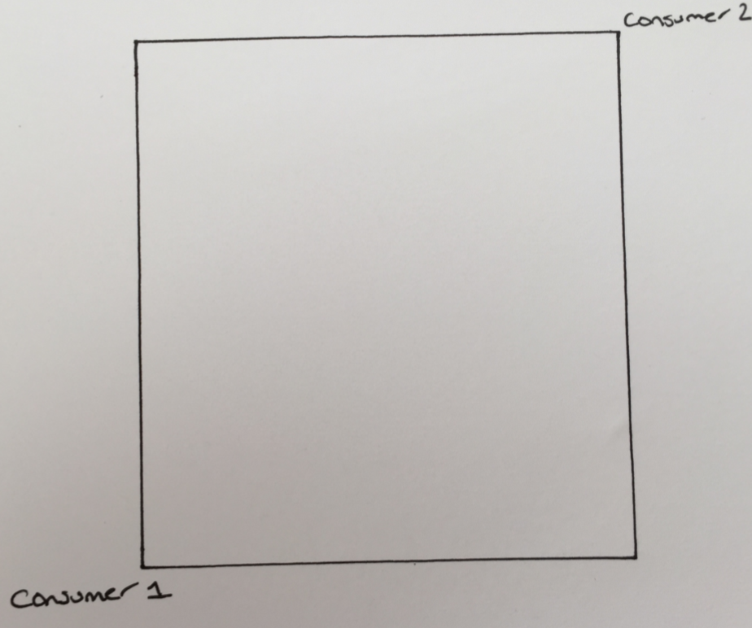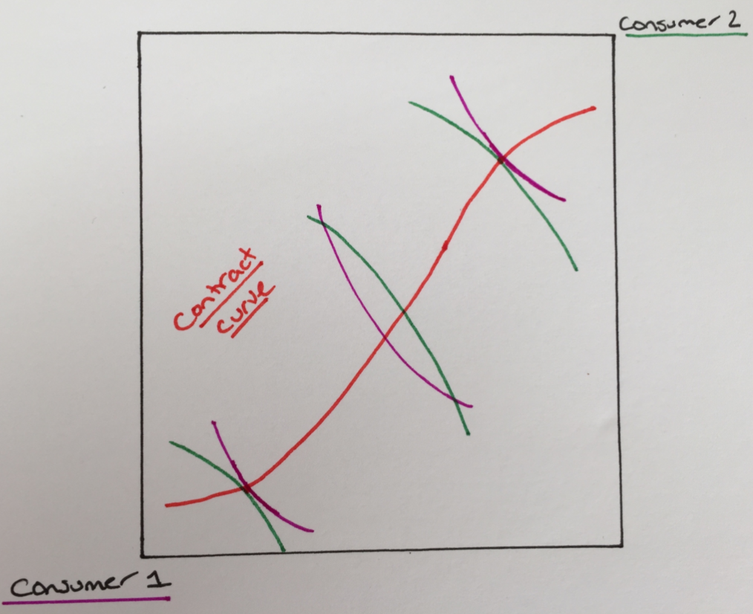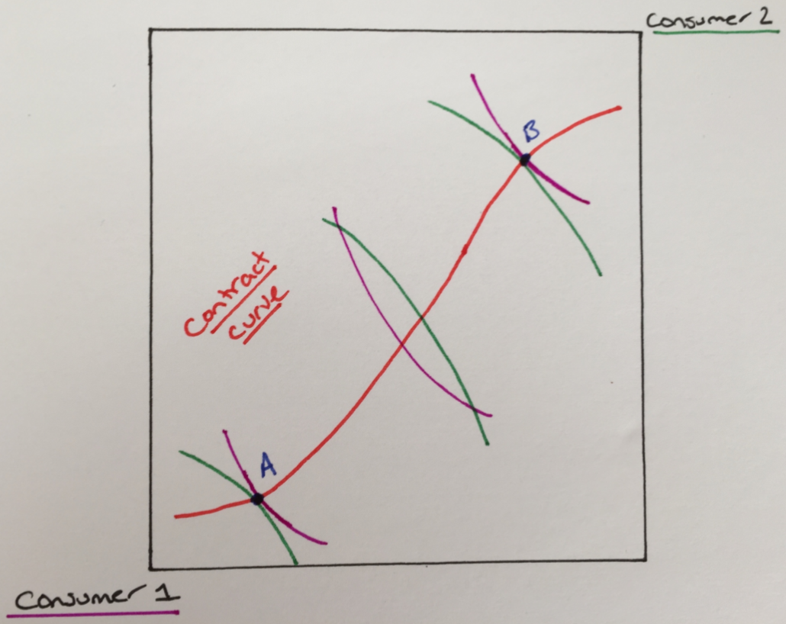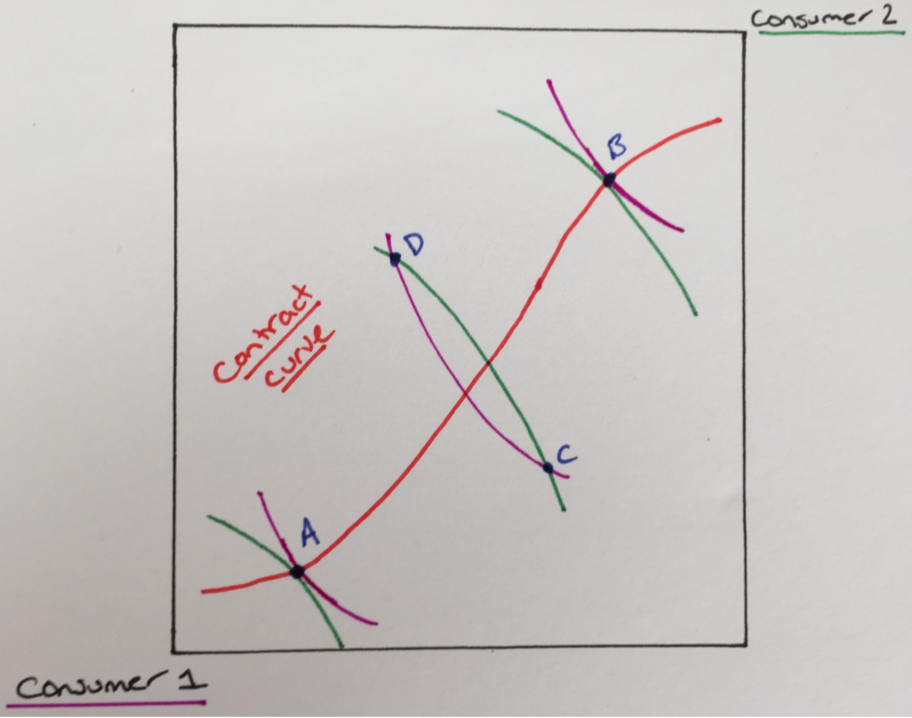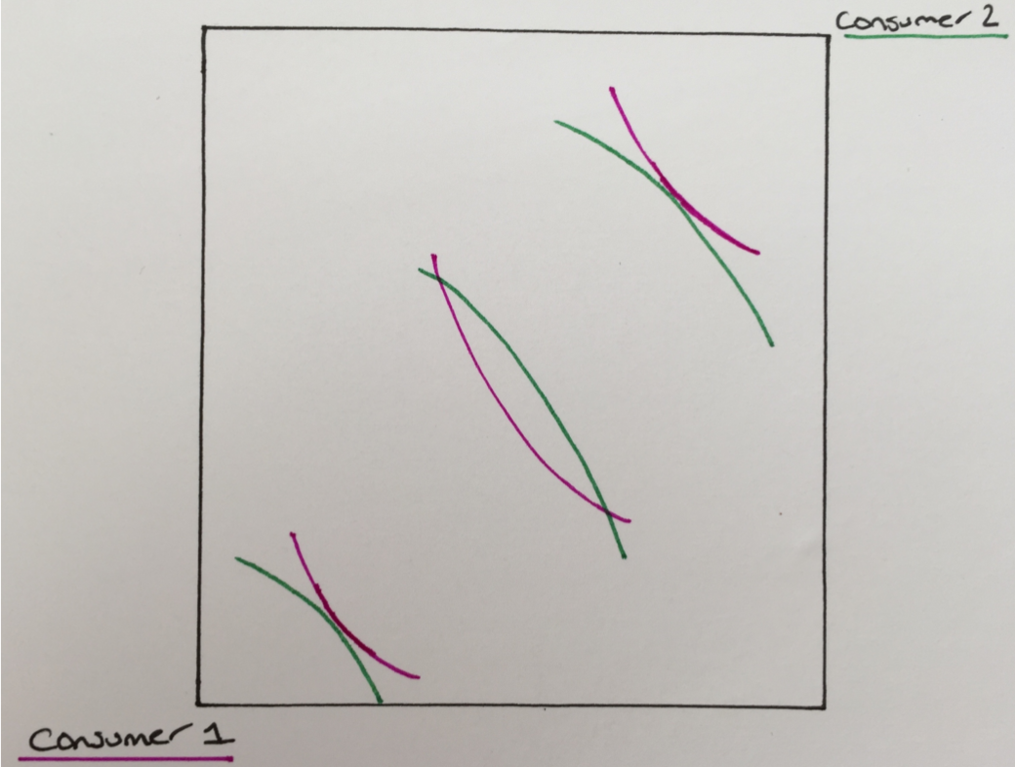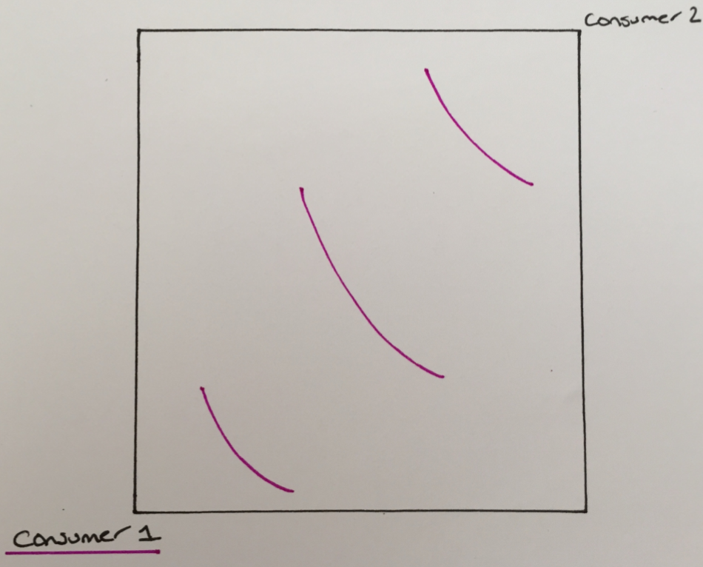– need both unable to be better off (Pareto)

🡪 🡪

🡪 🡪

**1.3: Social Planner**

* 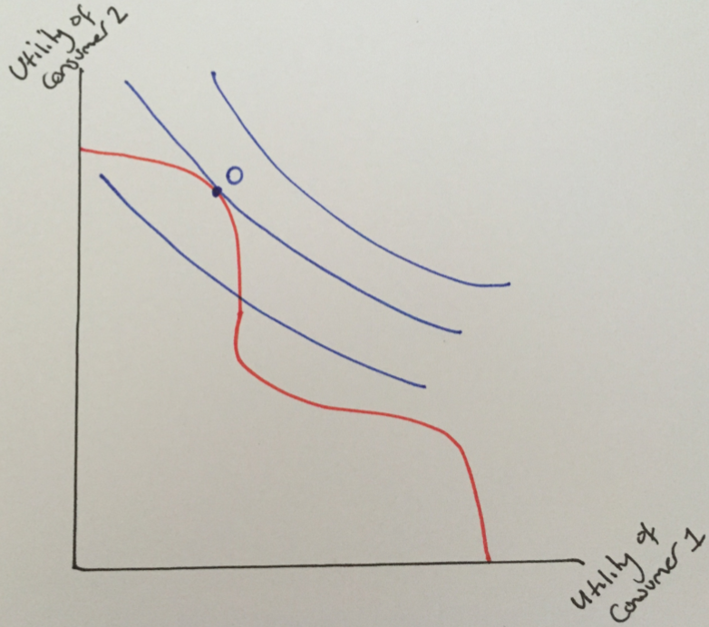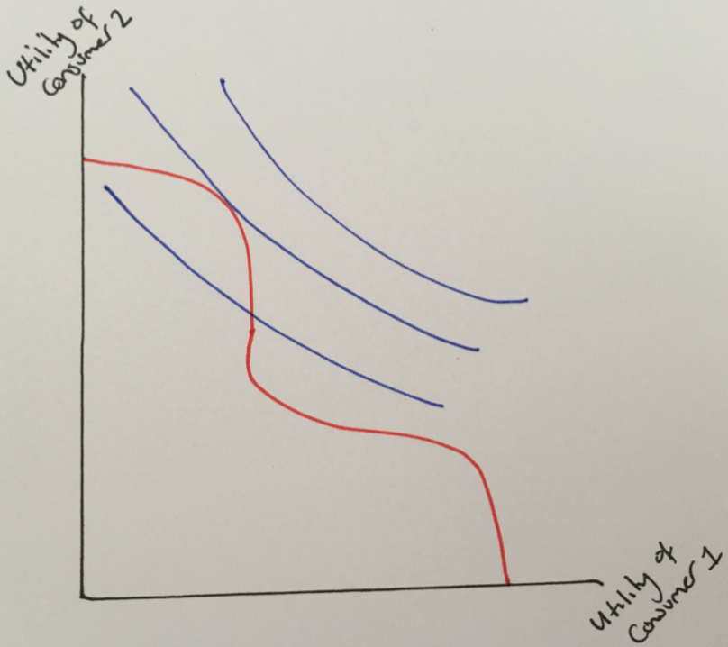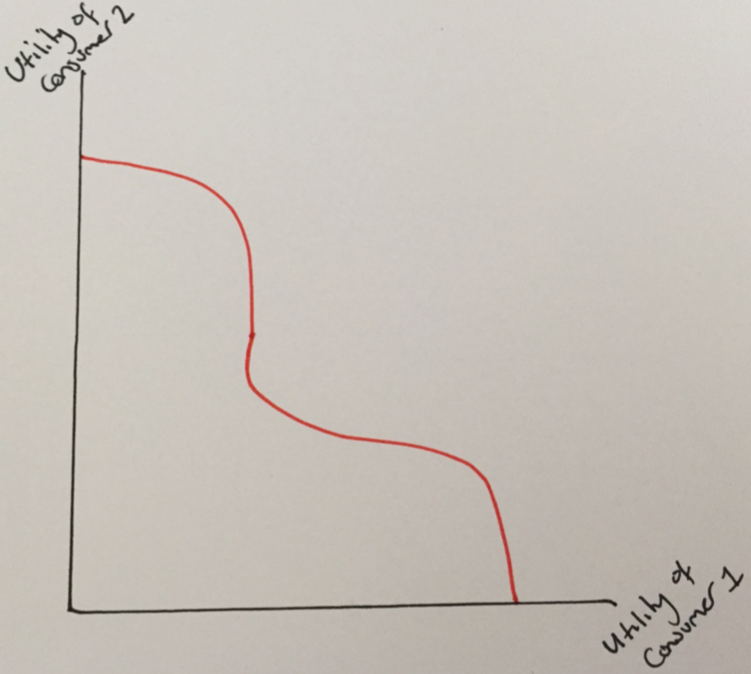*“How much of* ***x****’s utility should be traded-off for more efficiency (given to* ***y****)?”*

🡪 🡪

**1.4: Individual to Aggregate Utility**

* Aggregate Utility: given individual happiness (Utility), what’s the social happiness (Welfare)
* Hence, denote ***W***: Welfare
* *Depending on Social Planner or Society:*
* **Utilitarian**: ***W*** = U2 + U1 + … + UN
* **Rawlsian** ***W*** = min{U2 + U1 + … + UN}
  + *“If the lowest level of Utility is still quite high, we’re doing well”*

**1.5: How do We Achieve the Optimal Allocation?**

* Lump Sum Taxes – Social Planner Decides
  + Initial allocation
  + Some people too rich, some too poor
  + Hence, size of tax/transfer should depend on behaviour of consumers
* But much of information required for Redistribution is **private** 
  + Construct a Contract Curve based on individual preferences
* 2 Types of people (differentiated by ability)
  + Government (Social Planner) observes these abilities perfectly
  + ***sl:* Low Ability**: not as efficient (lower output)
  + ***sh:* High Ability**: efficient (higher output)
  + Equal numbers of the above
  + ***x:*** Consumption; ***l:*** Labour
  + Same utility function for both: ***U(x,l) = u(x) – v(l)***
$\frac{dU}{dx}>0;\frac{d^{2}U}{{dx}^{2}}<0$

$\frac{dU}{dl}<0;\frac{d^{2}U}{{dl}^{2}}>0$

* Lump-Sum Taxes
  + Individual ***sh*** pays tax: ***Ti*** if ***Ti*** > 0 or if ***Ti*** < 0
  + *“At what rate do you turn additional labour into additional consumption?”*
  + Higher ability people are more efficient at this
  + **Budget Constraint**: $x_{i}=s_{i}l_{i}-T_{i}$
* Individual *i*trades-off MU of consumption with Mdis-Utility of labour:
$s_{i}:\frac{du}{dxi}-\frac{dv}{dli}=0$

* Utilitarian: to maximise total U
$\max{\sum_{l,h}{u(s_{i}l_{i}\left(T_{i})-T_{i}\right)-v(l_{i}(T_{i}))}}$

* Government must run balanced budget:
$T_{h}+T_{l}=0 where: \frac{du}{dxh}=\frac{du}{dxl}$

* As MU is decreasing in ***x***, suggests $x_{h}= x_{l}$
* Recall **Optimal Labour (1):** balance of MU *x* with Mdis-U *l*
* And **Equality of Consumption** **(2):** between (*i*) types *h* & *l*:
$\frac{dv}{dl_{l}}=s_{l}\frac{dv}{dx_{l}}<\frac{dv}{dl_{h}}=s_{h}\frac{dv}{dx_{h}}$

* Notes:
  + With Mdis-U of *l*, optimal **Lump-Sum Taxes** ought to induce *h* to work harder than type *l* so this inequality implies $l_{h}>l_{l}$
  + **Note**: $x_{l}=x_{h}$; **So**: (Post-Redistribution) $U_{l}>U_{h}$
    - Higher ability people need to work harder for higher consumption so will they may lose incentive to be observed low ability
    - Government is trying to make the higher ability people work harder but here the more able people work harder but end up worse-off
    - **Optimal Lump-Sum Taxes** are **NOT** incentive compatible

**1.6: Measuring Inequality**

1. Range of M
2. Relative Mean Deviation of M
3. Coefficient of Variation
4. Gini
5. Lorenz Curve

* Note that vertical brackets represents absolute value – neglect negative signs

***1.6.1: Range of M***

$R=\frac{M^{H}-M^{1}}{H_{μ}}$

***1.6.2: Relative Mean Deviation of M***

$D=\frac{\sum{\left|μ-M^{h}\right|}}{2(H-1)μ}$

***1.6.3: Coefficient of Variation***

$σ=\sqrt{\frac{\sum{{(M^{h}-μ)}^{2}}}{H}}$

$C=\frac{σ}{{μ(H-1)}^{\frac{1}{2}}}$

***1.6.4: Gini***

* + Compares all possible pairs of income – selects minimum in each pair
  + Sensitive to transfers from rich to poor
  + **Not dependent** on position in distribution: house 8 to 6 same effect as 4 to 2
  + Only **dependent** upon the distance in between them

***1.6.5: Lorenz Curve***

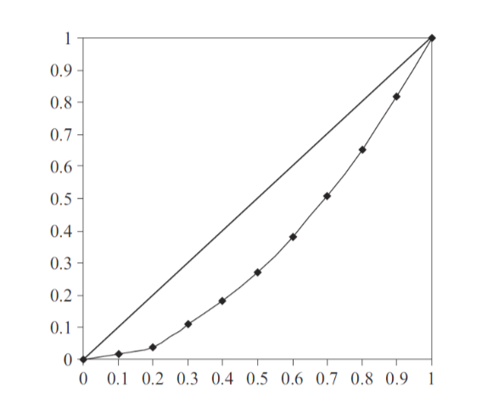

* *y*-axis: share of income
* *x*-axis: share of the population
* Rank income distribution based on degree of equality
* The area of the triangle below **line of equality** is $\frac{1}{2}$
 $G=Line of Equality-Lorenz Curve$

 + i.e. the area in-between

**1.7: Inequality & Welfare**

* All of the above imply something about welfare
* **Assumes**: (1) Symmetry; (2) Concave Indifference Curve
* If two distributions:
  + (1) Have equal means;
  + (2) Lorenz Curves don’t cross:
  + Distribution closest to the line of equality means higher welfare

$\frac{dW}{dM^{i}}≥\frac{dW}{dM^{j}} if M^{i}<M^{j}$

**2: Commodity & Income Tax**

* Commodity Taxes are levied upon goods
* Distort consumer choices
* Raise desired revenue; maximise Welfare
* **Efficiency** over **equity**

**2.1: Commodity Tax**

* Deadweight Loss of commodity taxing
* Calculating Deadweight Tax

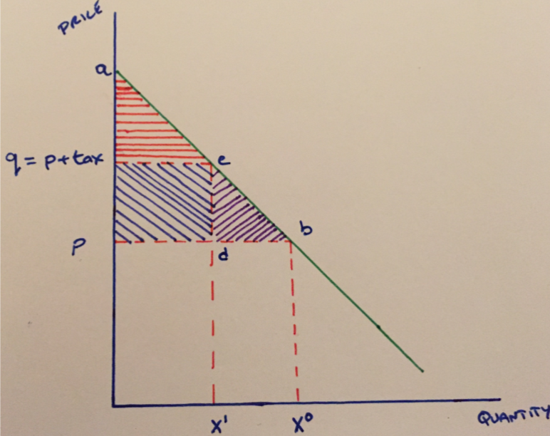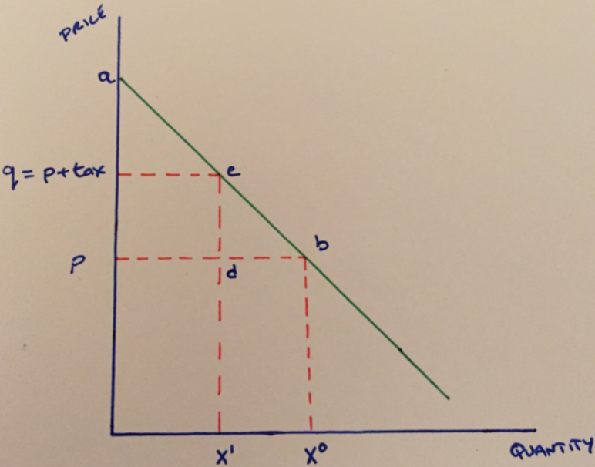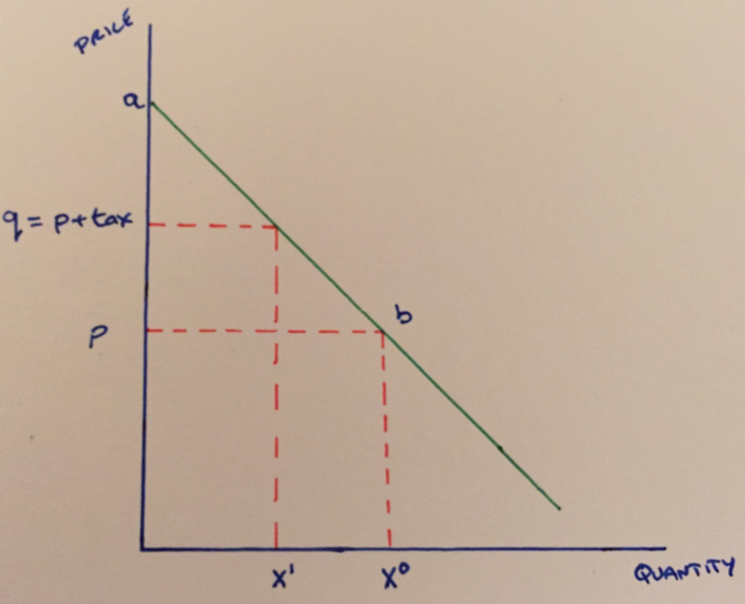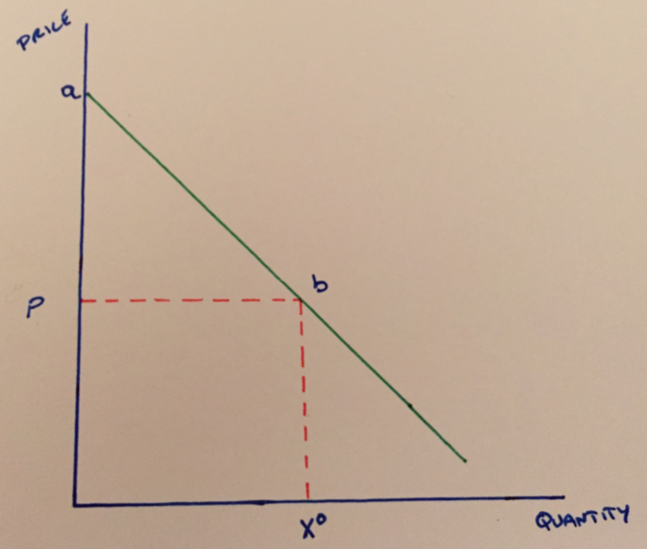

🡪 🡪

🡪

***2.1.1: Measuring the Deadweight Loss***

* Triangle *‘edb’*
 $DWL=\frac{1}{2}(\left(X^{0}-X^{1}\right)t)$

 $DWL=\frac{1}{2}\left(\left|ε^{d}\right|\frac{X^{0}}{p}t^{2}\right)$

+ Recall:

$ε^{d}=\frac{p}{X}\frac{dX}{dp}$

***2.1.2: Comparing Commodity to LS Taxes***

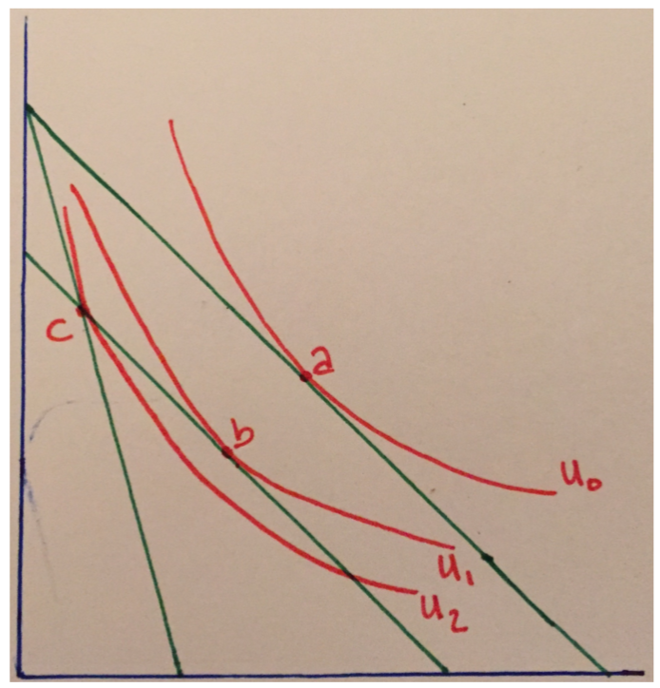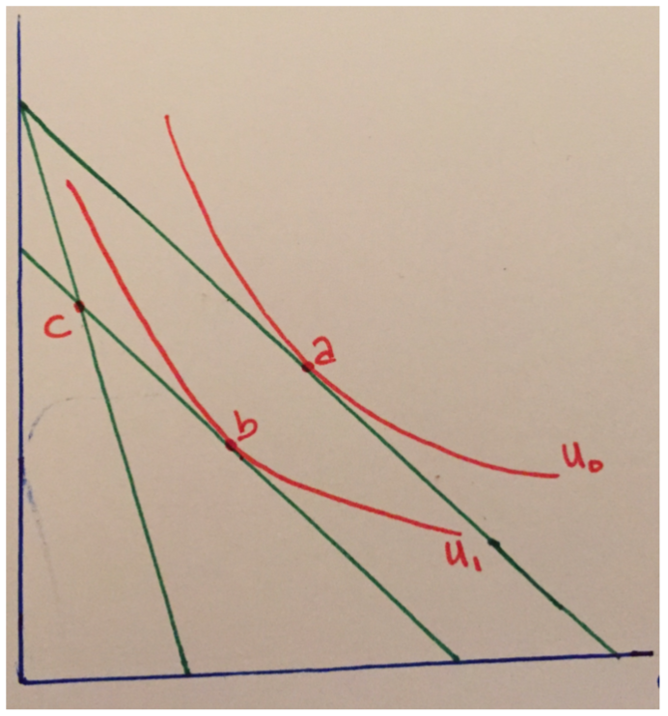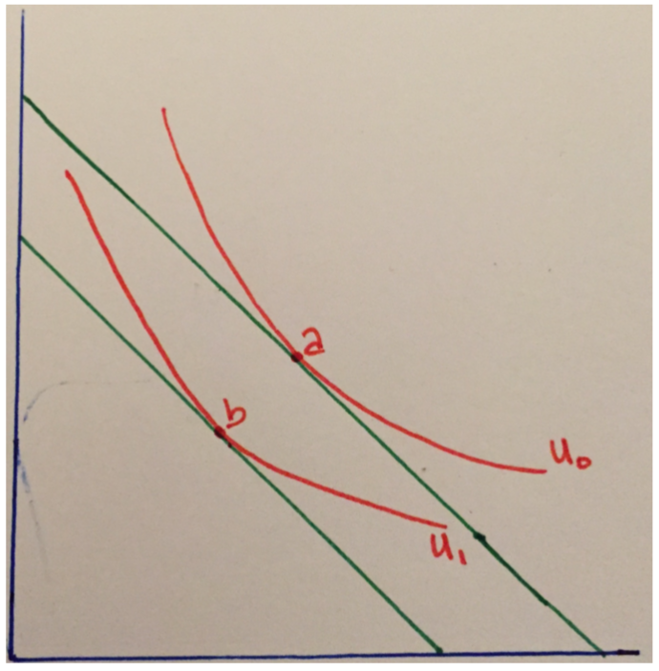

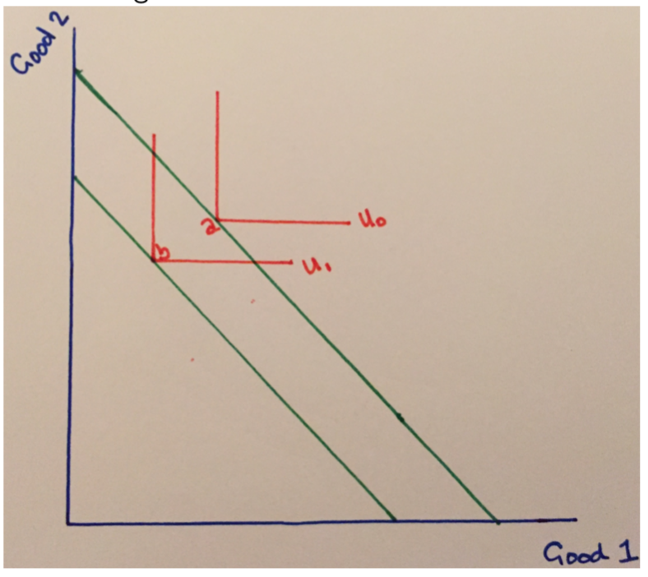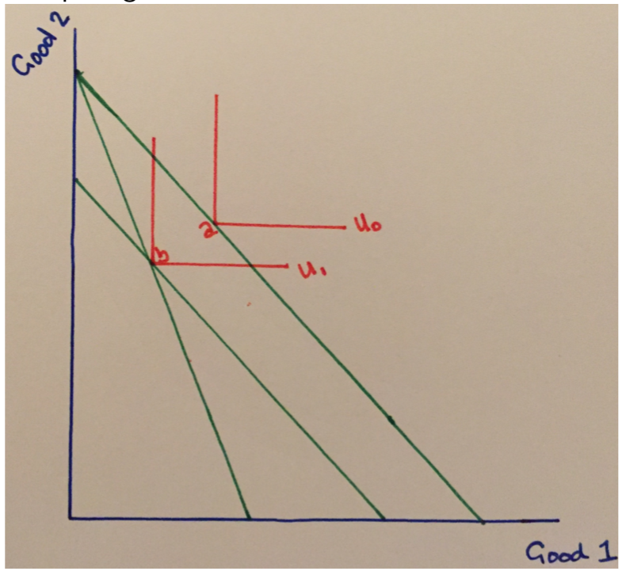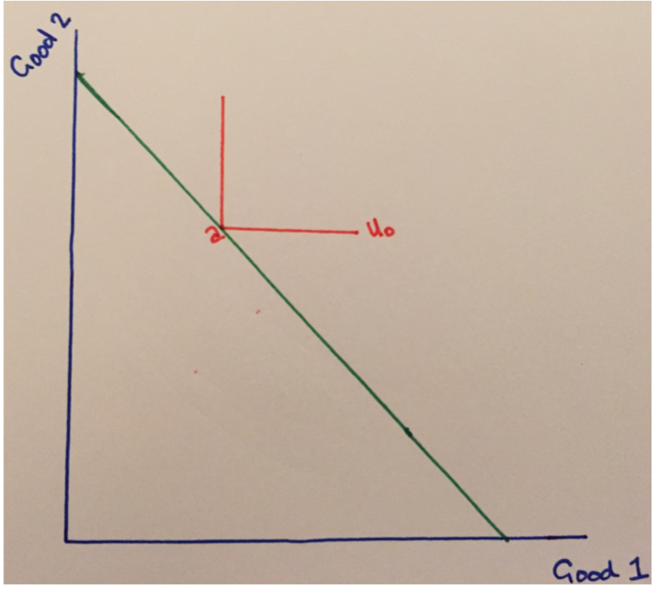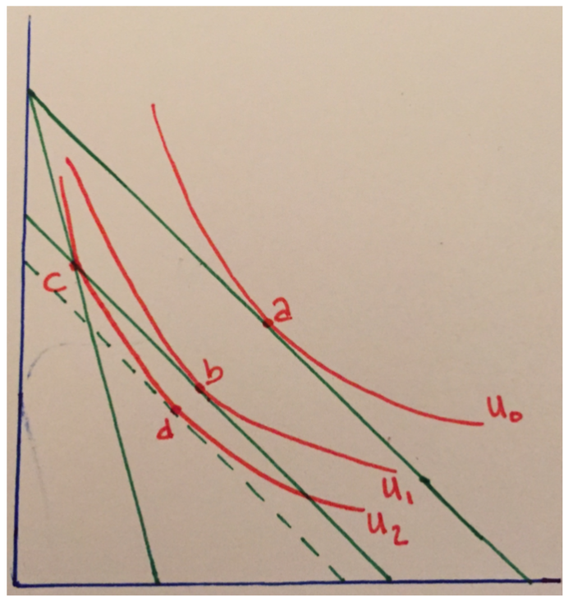

🡪 🡪 🡪

🡪 🡪 🡪

* Bottom 3:
* 2 goods – **perfect compliments**
* Introducing LS taxes
* Comparing CT and LST where R is constant

**2.2: Optimal Taxation**

* Firm
* Consumer
* Two Goods (labour (*l*) and consumption (*x*))

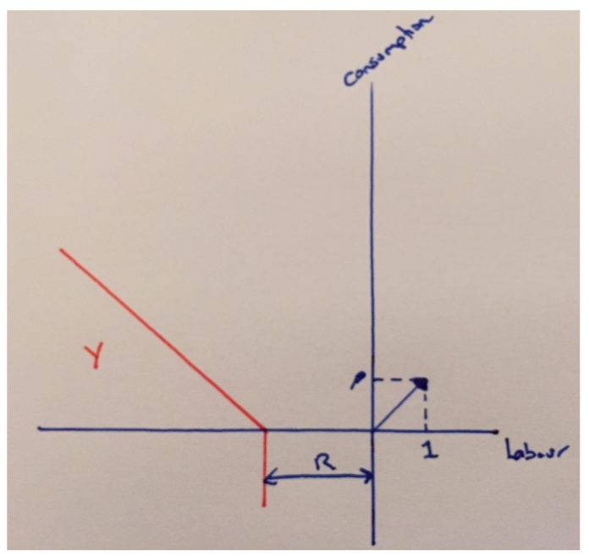***2.2.1: Production in Robinson Crusoe World***

$Normalise Wages=1$

$p=Price$

$π=0$

$R=Tax Revenue$

***2.2.2: Production in Robinson Crusoe World***

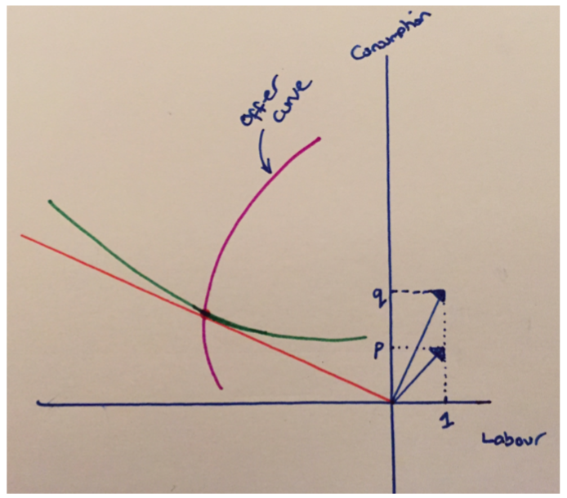

$I=qx=Consumer Budget Constraint$

$q⟹Price Consumer Pays$

$p⟹Price Firm Recieves$

***2.2.3: Optimal Commodity Taxation***

* Combine **producer** and **consumer**
* Consumption limited by Production Frontier
* Optimal @ $e$ with $t^{*}$ and

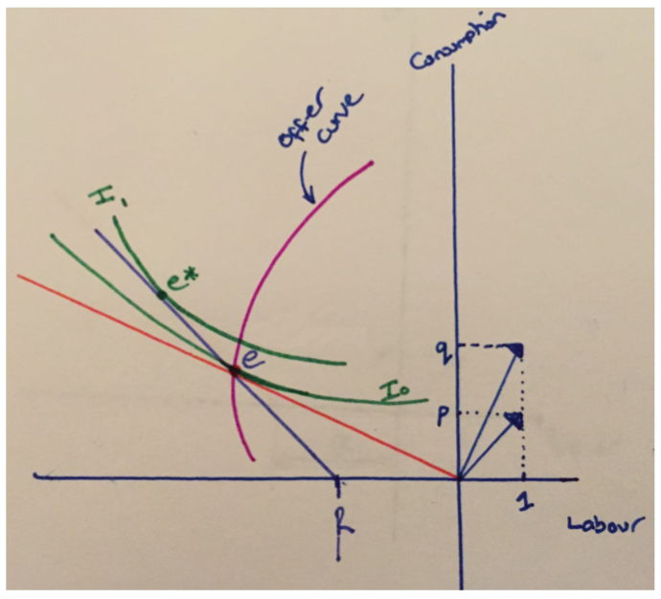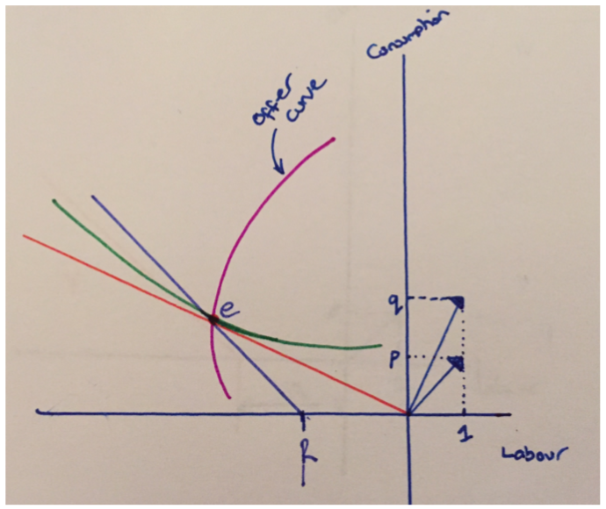

🡪

**2.3: Recap So Far**

* CTs are 2nd best
* DWL of CT > LST
* DWL driven by Substitution Effect
* Optimal CTs

**2.4: Income Tax**

* (1) Equity
* (2) Efficiency
* Relationship between **labour taxes** and **labour supply**
* Identify importance of **equity** and **efficiency**

***2.4.1: Top Marginal Rate of Tax***

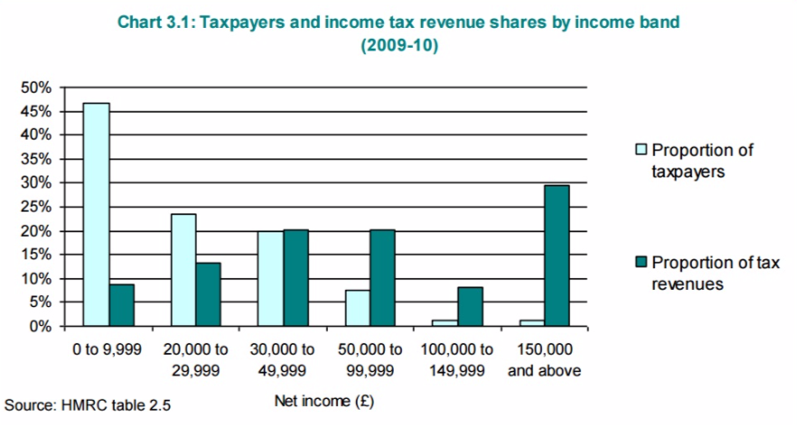

***2.4.2: Modelling Consumer Choice***

|  |  |
| --- | --- |
| $$U=U\left(x,\left(L-l\right)\right)=U\left(x,l\right)$$ | |
| $$L=Time$$ $$l=Labour$$ $$\left(L-l\right)=Leisure$$ $$w=Wage$$ $$t=Tax Rate$$ $$z=wl=Pre Tax Income$$ $$Consume x at Price p$$**2.5: Graphing Income Tax** |  |

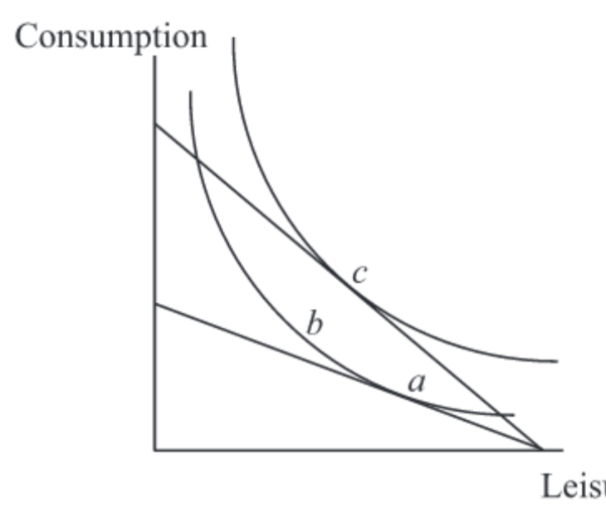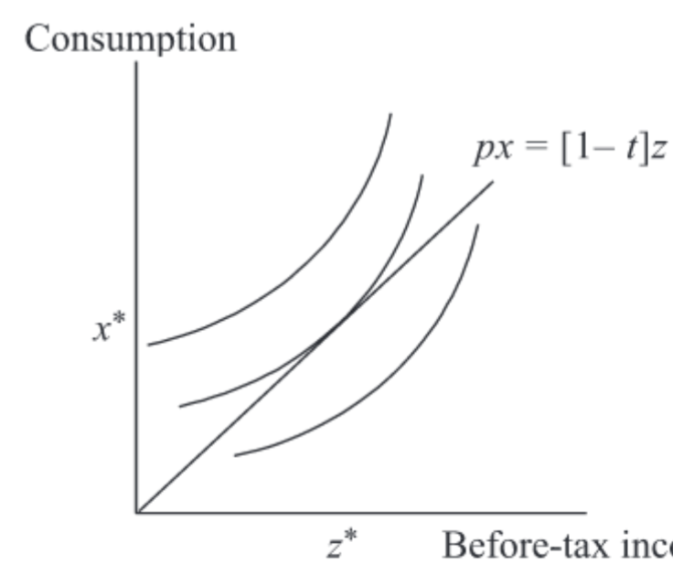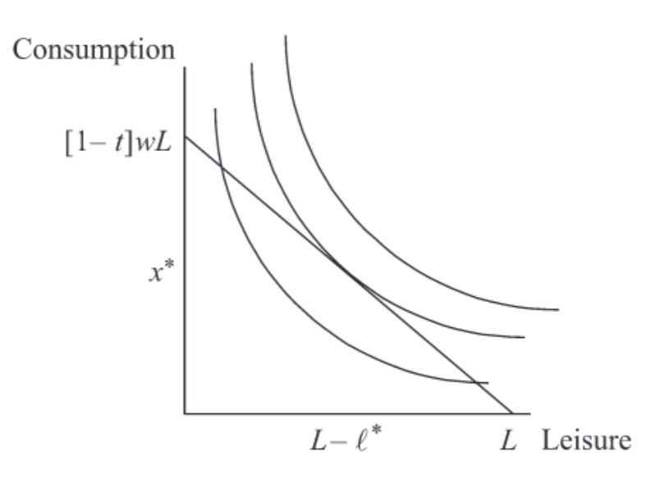

🡪 🡪

* 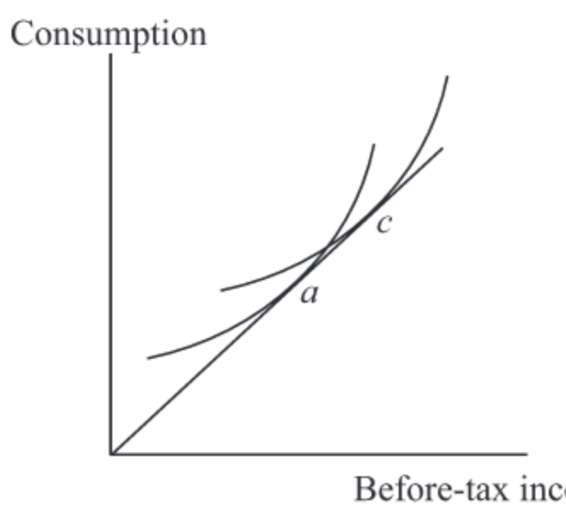Increase in $w$ by 3rd graph – decides $t$
* Effects: Income & Substitution
* No $∆$ in Budget Line by graph 4

🡪

**2.6: Graphing Income Tax w/ Thresholds**

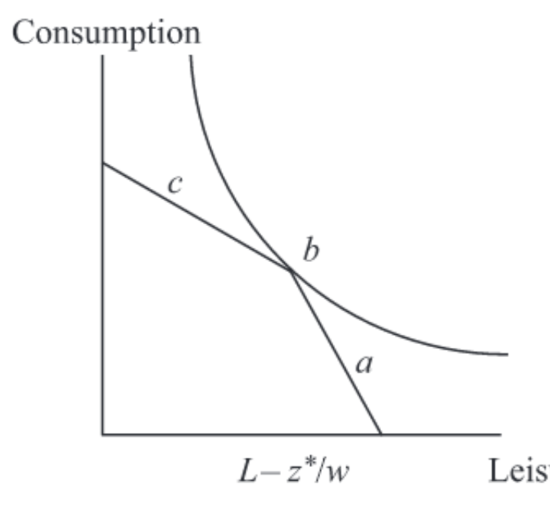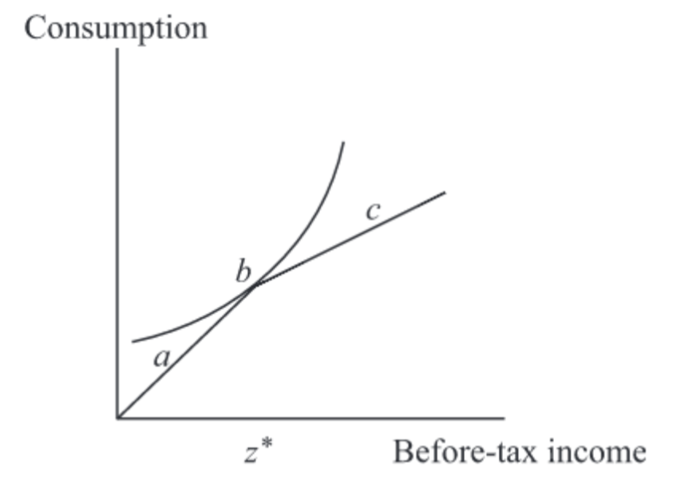

🡪

* Threshold of $z$@ $w$ arising @ hours $\frac{z^{*}}{w}$
* Where: $\left(L- \frac{z^{*}}{w}\right)=Hours of Leisure$
* MB on either side of kink
  + $w\left(1-t\right)$ vs. $w$

**5: Programme & Policy Evaluation**

* What can data tell us?
* Important relationship with **inputs** and **outputs**
  + Does more money in necessarily mean more output?
* Not a direct relationship through **cause** and **effect**
  + Cause: Policy Makers; Effect: Outcomes
  + i.e. could be no causal link between cause and effect
  + i.e. may all be caused through intermediate links
  + e.g. students with higher debt are more likely to drop out
* Basically: what is the most **optimal allocation** of resources?

**5.1: What Can Data Tell Us?**

Intermediate Factors

Cause

Effect

* e.g. students with higher debt are more likely to drop out (usually from poorer backgrounds) – also less likely to complete their course
* *Correlation:* Cause & Effect
* **Cause**: higher debt
* **Intermediaries**: poorer backgrounds, more distractions etc.
* **Effect**: higher drop-out rate

***5.1.1: Omitted Variable Bias***

* E.g. choosing a university:
* Measurable Variables: grades etc.
* Omitted Variables: determination, stamina, effort etc. (**unmeasurable**)
  + Regression result are omitted variable biased
* Cannot control for these variables
* **Example**: “effect on earnings w/ 1 additional year of schooling”
$wages=α+βeducation+u$

* However: if you aren’t in employment, you don’t have a wage - $β$ is biased
* Best if results are **random**
* Therefore, **sum of effects** rather than true **casual path**

**5.2: Randomised Control Trial (RCT)**

* Treatedgroup andControlgroup
  + **Treated** group goes under intervention
  + Intervention vs. untreated
* Individuals are randomly allocated to two groups (characteristics of samples should average at the same – “ two identical groups”)

***5.2.1: Law of Large Numbers (LLN)***

* + “As we increase the sample size, the **sample mean** gets closer to the **population mean”**

***5.2.2: Unbiased Estimator***

* $x_{N}$ is a good estimator of $E(x_{i})$
  + Population mean is a good estimator of expected observation
* With LLN and large samples, $x_{N}$ and $x_{i}$ are likely to be close
  + Taking multiple random samples mean, the averages would be the population mean
  + Therefore, Unbiased Estimator of the parameter

***5.2.3: Measuring Variability & Standard Error***

*“Is the causal effect by chance or is it true?”*

* Must observe magnitude
* Is the difference statistically significantly different from 0?
* Has the **treatment** (treatment group) had an effect?
* **Is the value I’m getting in the tails of the distributions? (t-test)?**
* Sample Variance: $σ_{x_{s}}^{2}=\frac{1}{N}\sum{{(x_{i}-\overline{x})}^{2}}$
* Population Variance: $σ_{x_{p}}^{2}={E((x_{i}-{E(x}_{i}))}^{2})$
* Standard Error: $σ_{\overline{x}}=\frac{σ_{x_{s}}^{2}}{\sqrt{N}}$
  + Summarising variability due to random sampling

***5.2.4: Using t-stats***

* T-Stat:
  + H0: “No difference in expected and population mean”
  + If true, $t\left(μ\right)$ has a **sampling distribution** close to **normal distribution**
  + Recall interpretation
* In context of Treated and Control:
  + Avg. outcome of **Treated**: ${\overline{Y}}^{T}$
  + Avg. outcome of **Control**: ${\overline{Y}}^{C}$
  + Sample Size: $N=n_{0}+n_{1}$
  + Causal Effect (is difference): (${\overline{Y}}^{T}-{\overline{Y}}^{C})$
* Hence: $t\left(μ\right)=\frac{( {(\overline{Y}}^{T}- {\overline{Y}}^{C})-μ)}{σ_{{(\overline{Y}}^{T}- {\overline{Y}}^{C})}}$

***5.2.5: What Makes RCT Not Possible?***

* Logistical
* Undesirable from policy perspective
* Ethical (e.g. flipping a coin to allow someone to eat)

**5.3: Regression in Practice**

* Equal variables made by **treated** and **controlled**, selection bias mostly removed
* **Example:**
  + Steve (Oxford - fees), Eve (Strathclyde – no fees)
  + *Is it worth it?*
  + I.e. we want to see the difference in an identical person’s income at the age of 40 if they’d (1) studied at Oxford or (2) at Strathclyde
  + Oxford vs. Strath: £34,000 vs. £27,000
  + **But**: what about ‘motivation’, ‘skills’, ‘effort’ etc.
    - E.g. people accepted by Oxford but rejected it
    - Hence, Omitted Variable Bias as not accounting for some **characteristics**

***5.3.1: Example cont. w/ Regression***

* Control for **observable differences** in two parties
* Seeking: Other Things Equal comparison
  + If all that mattered was Highers and Uni attended: Ceteris Paribus comparison
  + Steve (male), Eve (female) – gender pay gap issue
  + If only **gender** matters: replace Steve w/ any (Oxford) female
  + Look for large no. of grade/gender matches across universities
  + Matching Estimator: avg. difference in Oxford vs. Strath earnings to estimate **causal effect** – assumes equivalent earnings potential in **gender**/**Highers**
  + But, unobservable factors beyond **gender**/**Highers**
  + Must control for all
* Dale & Kreuger Solution:
  + Observe which universities were applied to (**motivation**)
  + Observe which universities they were admitted to (**ability**)
  + E.g. two students applied to & admitted to same universities, (for reasons unrelated to earnings potential) choose different ones

***5.3.2: Regression Structure***

* + Where:

$P=Dummy of Public or Private Education (or Free or Fee)$

$A=Dummy of Which Group the Subjects Are In$

***5.3.3: Use of Instrumental Variables***

* + Where:
  + Earnings $Y$ at time $t$ by man $i$ in cohort $c$
  + And $s_{i}$ indicates veteran status and $β$ and $δ$ are dummies
  + And $α$ is the effect of military service on civilian earnings
    - If: $s_{i}$ uncorrelated with **unobserved** components of earnings
  + IV: is there correlation between $s_{i}$ and $u_{i}$?
    - Eligibility criteria for armed forced perhaps corr. w/ earnings but not controlled for
    - Veterans perhaps self-selected based on **unobservable** characteristics
    - Using IVs will estimate **casual effect** of veteran status on earnings

**6: Economics of Crime & Punishment**

* E.g. does incapacitating people reduce crime?
  + i.e. an unskilled criminal going to prison and leaving a skilled prisoner
  + You have only shifted the effect of him to the future and enhanced it
* E.g. investing in more police, what happens to crime rates?
  + Police aren’t randomly assigned to areas
  + Expect negative correlation but need **causal path**

**6.1: Ideas & Assumptions**

1. People respond to incentives of others
2. Able to assess peoples returns from committing crimes (e.g. losing a job)
3. Stable distribution of preferences for crime and crime prevention
4. Objective of law enforcement is to **maximise welfare**
5. Possible to aggregate individual preferences to arrive at equilibria

***6.1.1: Gary Berker’s Nobel Lecture***

* *Probability of*
* Option 1: get parking ticket and be on time for Nobel lecture
* Option 2: drive until a space appears, be late for Nobel lecture

***6.1.2: Intuition***

* Opportunity cost (loss in real income) of committing a crime
* Commit crime to get free pass to rehab
* Probability of punishment is 1 (caught – tried – found guilty)
* Severity of punishment
* Nature of punishment

**6.2: The Model**

* People have different **moral** **standards**, **enjoyment**, **risk** when it comes to crime
  + Some need huge payoffs (high Threshold)
  + Some need only small payoffs (low Threshold)

$i=Individual$

$l_{i}=Expected Payoff Per Offense (Minus Costs)$

$c_{i}=Cost Incurred if Caught$

$w_{i}=Wage Rate From Non Criminal Work$

$p_{i}=Probability of Aprehension \& Conviction$

$f_{i}=Punishment if Conviced$

***6.2.1: Expected Net Return (Supply)***

$$π_{i}=l_{i}-c_{i}-w_{i}-p_{i}(f_{i})$$

* Assumes
  + Normally distributed
  + Offenders risk neutral

***6.2.2: Normal Distribution***

* Left of the mean: need very low Threshold perhaps for crimes even non-beneficial
* Right of the mean: need very high Threshold

***6.2.3: Demand for Offenses (Demand)***

* E.g. clear demand for stolen goods etc., not so much for murder (unless hired killer)
* Value not being a victim of crime: spend a lot of money on not being a victim (infers demand for defences)
  + Marginal Cost of additional unit of protection vs. Marginal Benefit
  + Choose a best-response
 $$e_{i}=Expenditure on Protection=f(v_{i},D_{i})$$

 $v_{i}=Risk of Being a Victim$

$D_{i}=Private Loss of Being a Victim$

$q_{i}=Average Crime Rate in Population$

$\frac{de_{i}}{dv{(q)}_{i}}>0$ + : *“Increases in crime rate, willing to spend more money ”*
  + $\frac{dc_{i}}{de_{i}}>0$: …
  + $\frac{dπ_{i}}{dc_{i}}<0$: *“As costs go up, net returns go down”*
  + *“As crime* ***increases****, demand for offenses* ***deceases****, marginal return for committing crime* ***decreases****”* – Diseconomies of Scale
  + Hence: ${d{(e}_{i})}_{i}=l_{i}-w_{i}-c(e_{i})$
  + So: $\frac{dd_{i}}{de{(q_{i})}_{i}}<0$: *“Want spend more on protection, suggests defence demand lowers”*

***6.2.4: Supply & Demand***

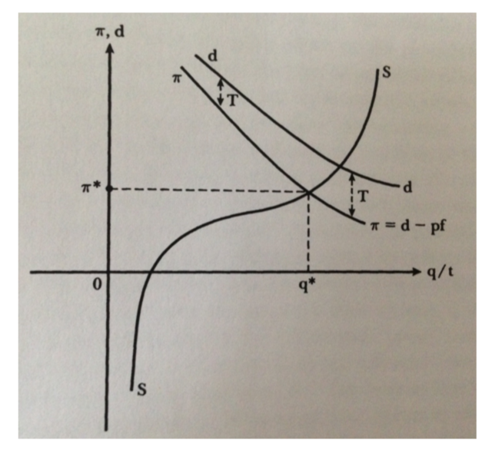

* Top **demand**: peoples personal demand for protection (dd)
* Bottom **demand**: introduce government – law, tax etc.
  + E.g. must tolerate some criminality as:
  + MC for catching last criminal is much bigger than MB
  + MC for catching first criminal is much smaller than MB
* **Supply**: increasing stationery point line

***6.2.5: p(f)***

* Recall: **neutrality** (increasing *p* by 1 has the same effect as increasing *f* by 1)
* Increase *p* is costly
* Increase *f* is near-costless

***6.2.6: Equilibrium***

* Everyone is on **best response**

1. Criminals: net return and cost from committing a crime
2. Private Citizens: risk and costs of victimisation
3. Government: social costs of crime and benefits from expenditure

$NCC=No Crime Condition=EU\left(Crime\right)≤EU\left(No Crime\right)$

$EU\left(Crime\right)=\left(1-p\right)u\left(l_{i}\right)-p_{i}u(l_{i}-f)$

$EU\left(No Crime\right)=u(w_{i})$

* Hence: no crime at above *NCC*

**6.3: Intuition**

* Judge: makes poorer decision if hot/hungry etc.
* Randomly assign judges
* Probability of someone’s conviction is a function of the judge they get